**Google project hosting and SVN**

1. 请到以下网址：<http://subclipse.tigris.org/> 阅读有关eclipse安装svn插件的相关说明，然后自己安装好subclipse插件。
2. 申请一个gmail账号，然后登入<http://code.google.com/hosting/>， create a new project, then use your eclipse’s subclipse plugin to create a new repository with the svn URL and password Google provide to you。
3. Create a new project in Eclipse and commit the entire project to your svn repository , and then check whether you successful upload your project file in Google’s server. 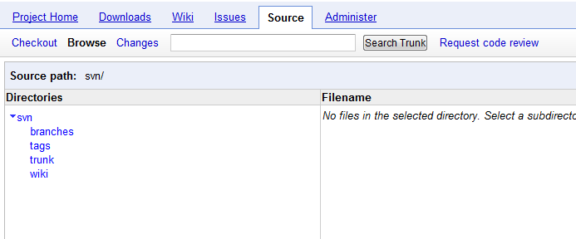
4. done